HANU Training Management System

Use-Case-Realization Specification: Course Registration (Student)

Version 1.0

*[Note: The following template is provided for use with the Rational Unified Process. Text enclosed in square brackets and displayed in blue italics (style=InfoBlue) is included to provide guidance to the author and should be deleted before publishing the document. A paragraph entered following this style will automatically be set to normal (style=Body Text).]*

*[To customize automatic fields in Microsoft Word (which display a gray background when selected), select File>Properties and replace the Title, Subject and Company fields with the appropriate information for this document. After closing the dialog, automatic fields may be updated throughout the document by selecting Edit>Select All (or Ctrl-A) and pressing F9, or simply click on the field and press F9. This must be done separately for Headers and Footers. Alt-F9 will toggle between displaying the field names and the field contents. See Word help for more information on working with fields.]*

Revision History

| **Date** | **Version** | **Description** | **Author** |
| --- | --- | --- | --- |
| 06/12/2021 | 1.0 | Final | Nguyễn Thị Thu Hiền |
|  |  |  |  |
|  |  |  |  |
|  |  |  |  |

Table of Contents

1. Introduction 2

1.1 Purpose 2

1.2 Scope 2

1.3 Definitions, Acronyms, and Abbreviations 2

1.4 References 2

1.5 Overview 2

2. Flow of Events—Design 2

3. Derived Requirements 2

Use-Case-Realization Specification: Course Registration (Student)

# Introduction

## Purpose

This document describes how the Course Registration Use-Case is realize the use-case requirements to programming objects and programming instructions, in order to successfully implement the use-case functionalities in later phases.

## Scope

This document is strictly associated with the Course Registration (Student) Use-Case.

## Definitions, Acronyms, and Abbreviations

none

## References

[1] Course Registration (Student) **– Usecase Specification**, Nguyễn Thị Thu Hiền, December 05, 2021, HANU Training Management

[2] Class/ Sequence Diagram: <https://app.diagrams.net/#G1ktXyro25JJ60rXaYjkn01-Bh4JUzT1Ws> were done by Nguyễn Thị Thu Hiền.

## Overview

The flow of events that were introduced textually in the use-case requirements is implemented in terms of cooperating objects in the second section. Class diagrams and sequence diagrams will be used to better describe its reality. If there are any additional needs derived from the realized diagrams, such as non-functional requirements or other requirements not included in the design model, they will be stated in section 3 – Derived Requirements.

# Flow of Events—Design

## Sequence diagram

* This use-case includes two smaller actions: choose one or more than one subject and save the registration.
* 1st diagram describes the flow of choosing one or more than one subject:

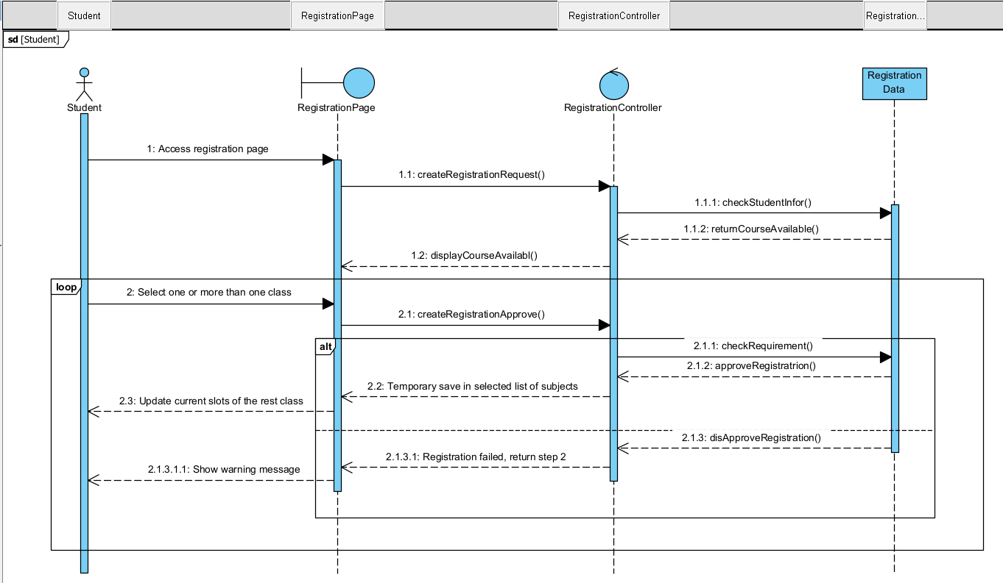

* 2nd diagram describes students saving their registration:

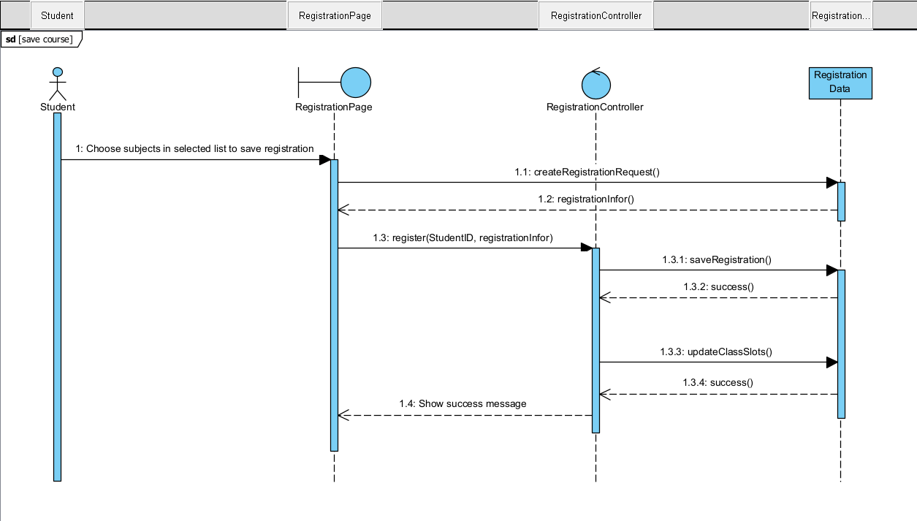

## class diagram

2.2.1. Overview

* This use-case involves 8 objects: RegistrationData, RegistrationPage, RegistrationController, Student, Course, CourseClass, Faculty and Semester.

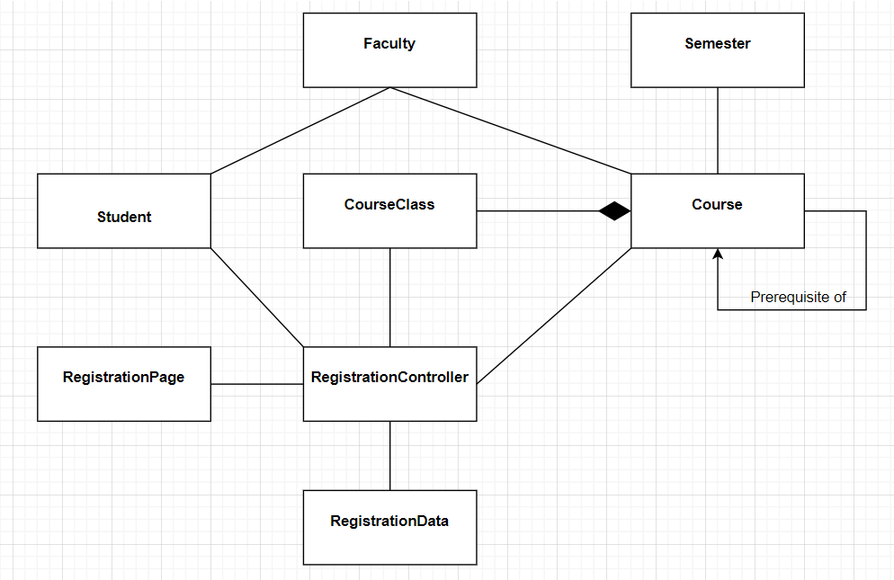

2.2.1. Details

1. Details of Semester, Faculty, Students, CourseClass, and Course:

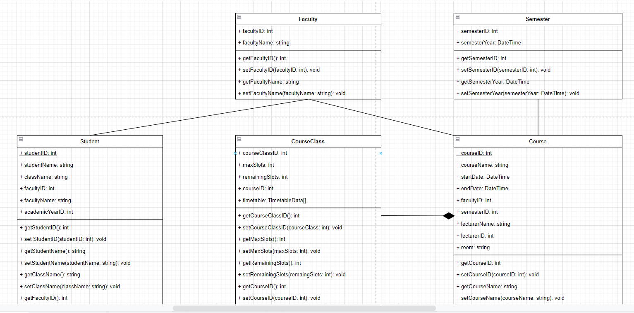

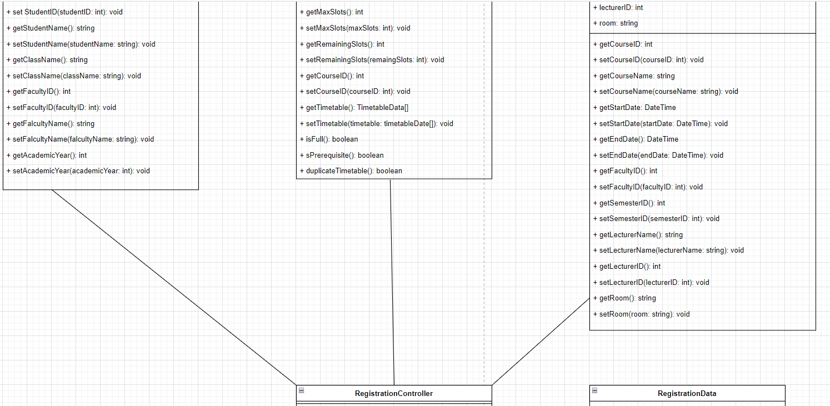

1. Details of RegistrationController, RegistrationData and RegistratrionPage:

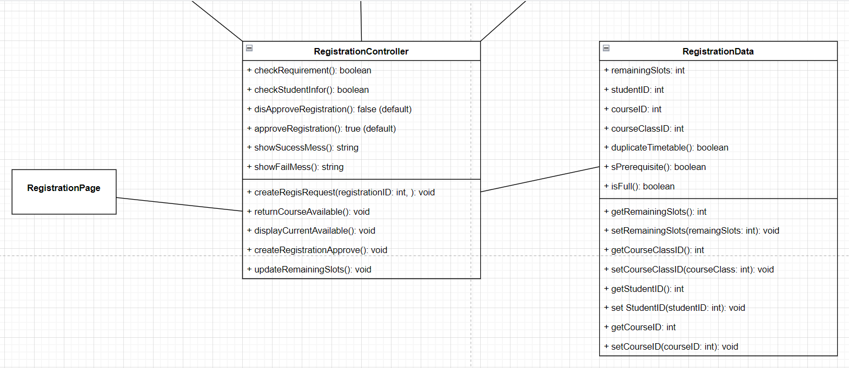

# Derived Requirements

* If having any error such as a server restart occurs or the Internet of students is unstable when registering, nothing is saved.